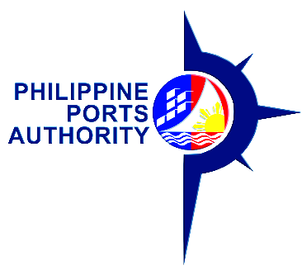

07 March 2022

**NOTICE OF PUBLIC HEARING**

**TO ALL STAKEHOLDERS:**

Notice is hereby given that the Philippine Ports Authority (PPA) will conduct a virtual Public Hearing on the **PROPOSED THREE (3) YEAR RENT ADJUSTMENT PROGRAM FOR CY 2022-2024** via **Zoom Application.**

Details of the Public Hearing are as follows:

DATE : March 18, 2022

TIME : 2:00 PM

CONTACT PERSON : Jorice A. Naranjo

CONTACT NUMBER : 0917-133-3991

0967-529-1128

EMAIL ADDRESS : [janaranjo@ppa.com.ph](mailto:janaranjo@ppa.com.ph)

[moc_opm@ppa.com.ph](mailto:moc_opm@ppa.com.ph)

All concerned parties especially those who will be affected by the proposed rent adjustment are invited to attend the virtual public hearing.

For further information, please coordinate with the above-named contact person.

**ISIDRO V. BUTASLAC, JR.**